|  |  |
| --- | --- |
| Document Owner |  |
| Owning Team | Author/s |
| SkyOnn Technologies (External Auditor) | Rajinikanth Veeraraghavan |

|  |  |  |  |
| --- | --- | --- | --- |
| Document History | |  |  |
| Author | Date | Version | Comment |

|  |  |  |  |
| --- | --- | --- | --- |
| Rajinikanth Veeraraghavan | 12/7/2017 | 0.1 | Draft version |
|  |  |  |  |

**Actions performed by the Tool**

**(Customer with existing credit records - No Duplicate Amount)**

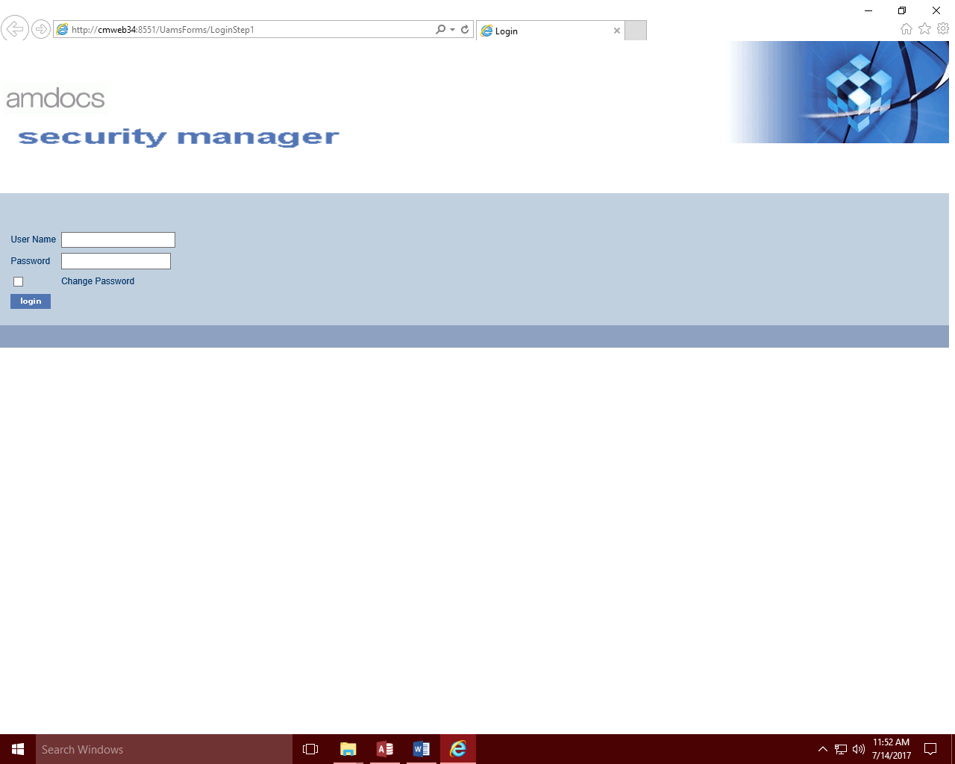

1. **Loading the Login Screen**

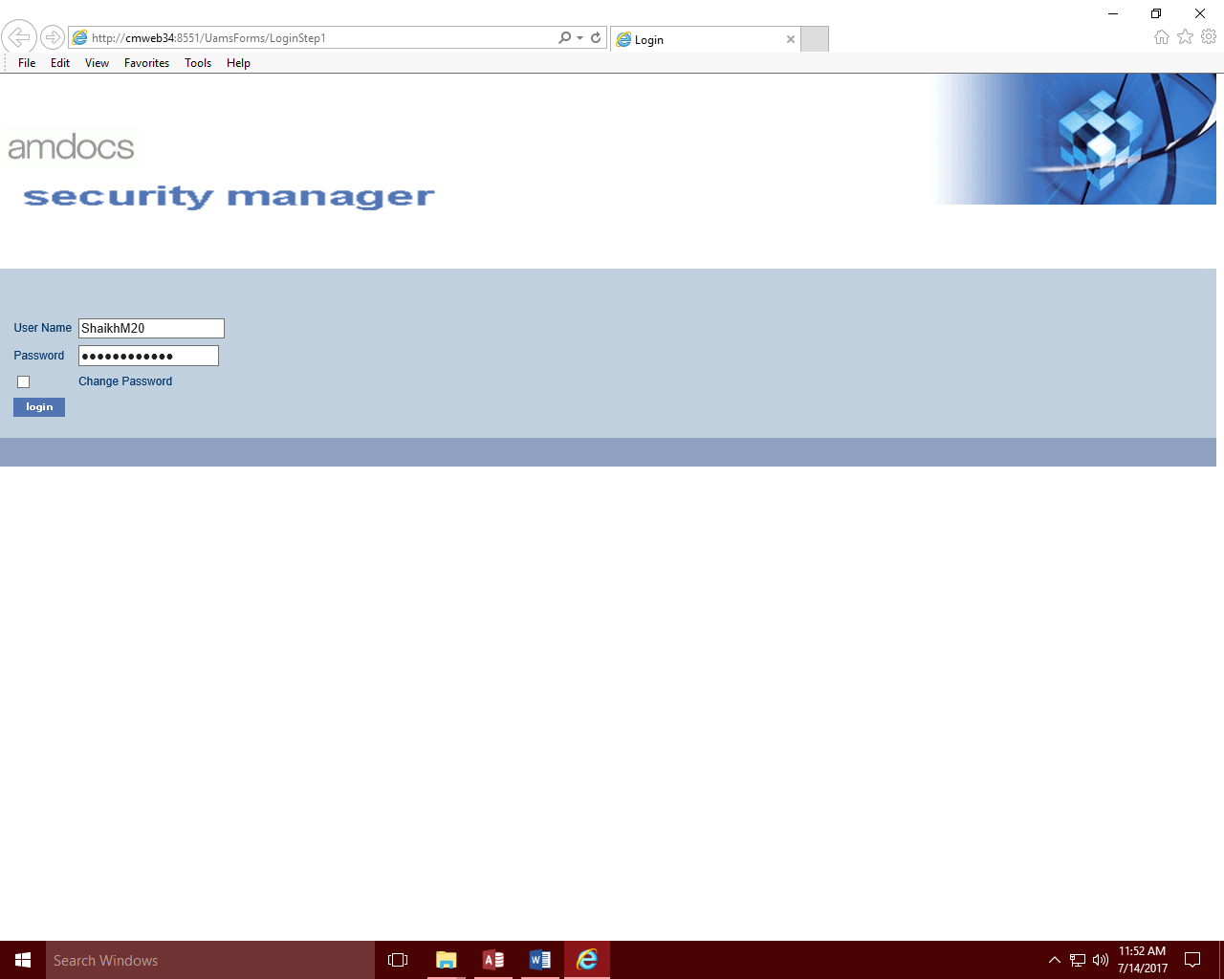

1. **Authentication: Login Information retrieved from the Tool and being populated**

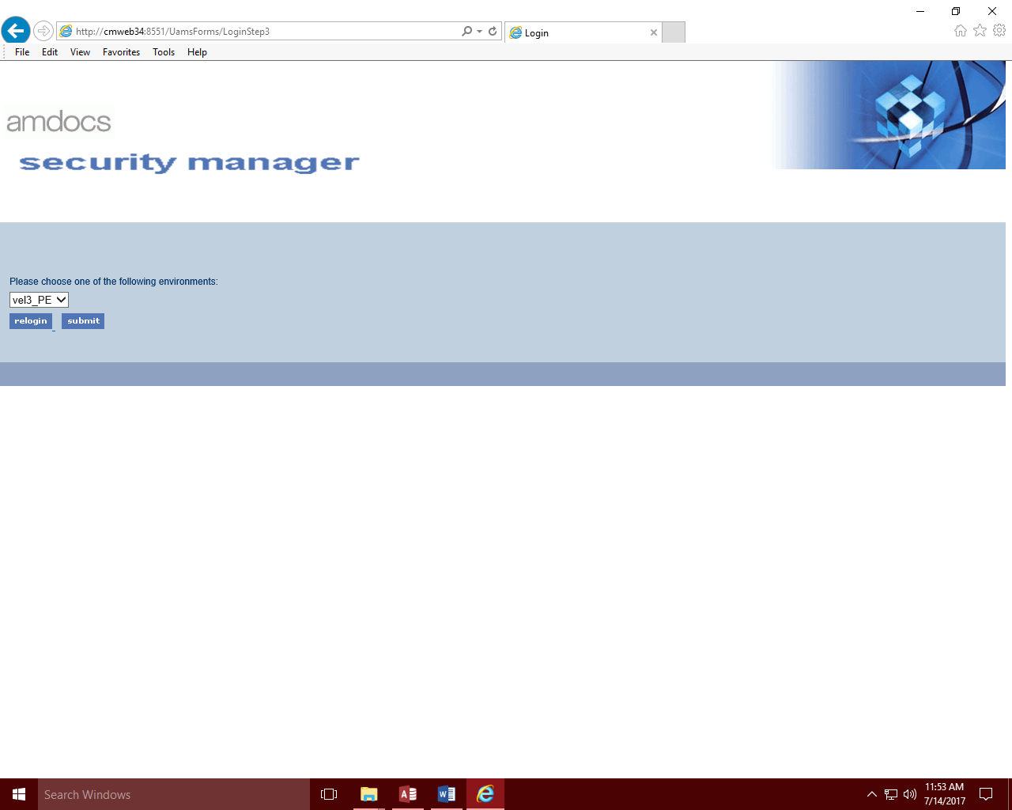

1. **Loading the environment selection screen on successful authentication**

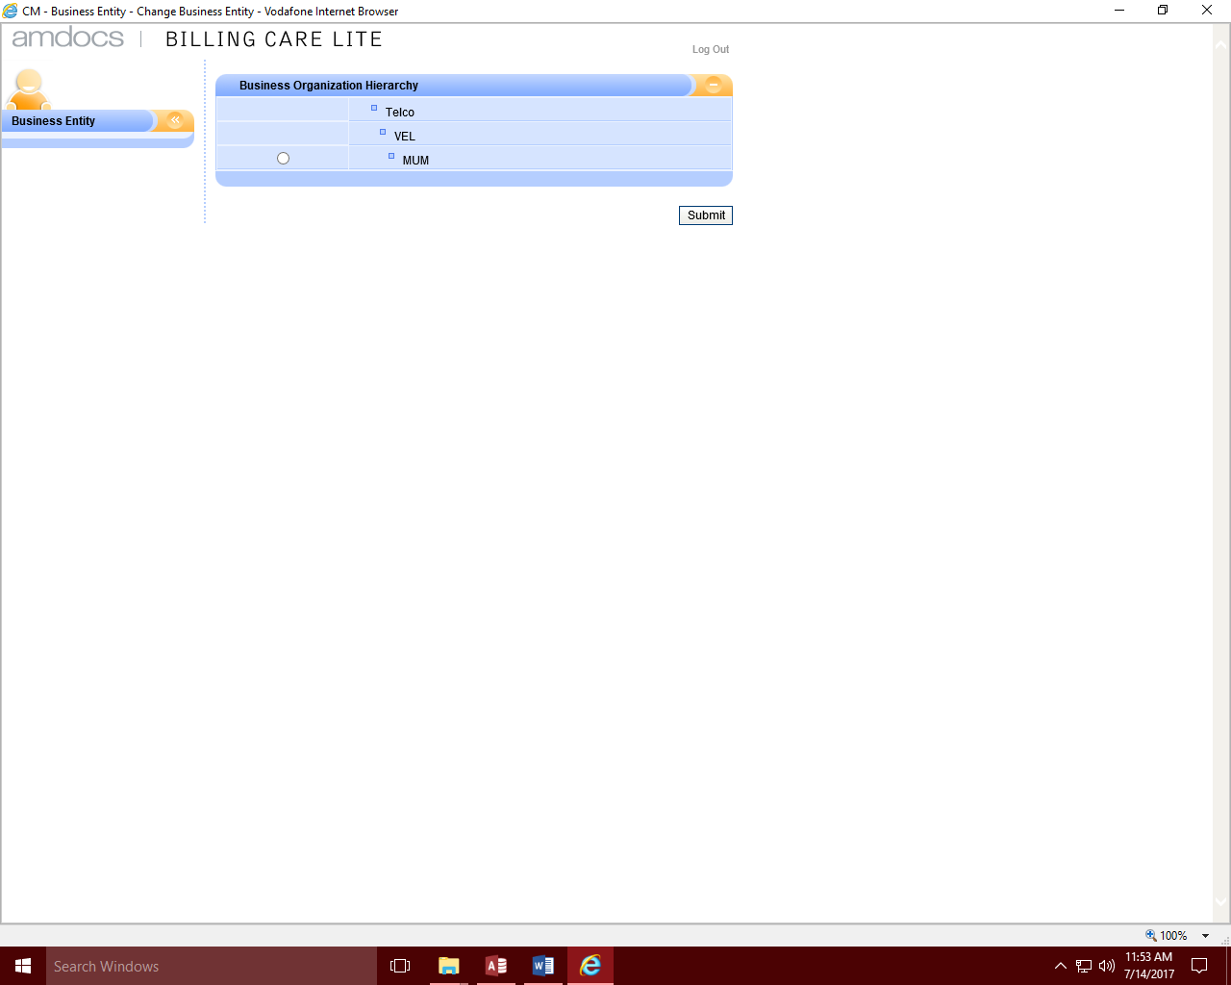

1. **Loading the Business Organisation hierarchy**

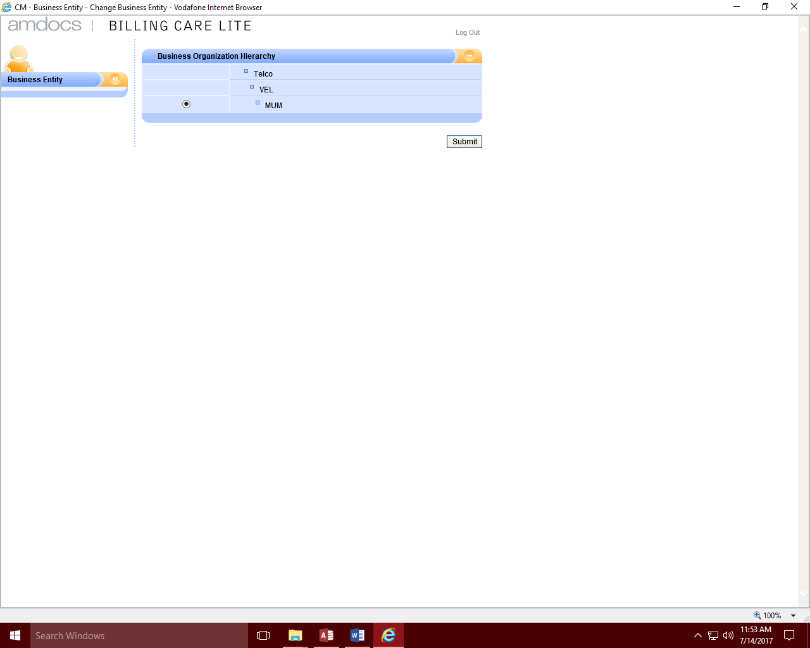

1. **Selecting the appropriate Business Organisation hierarchy**

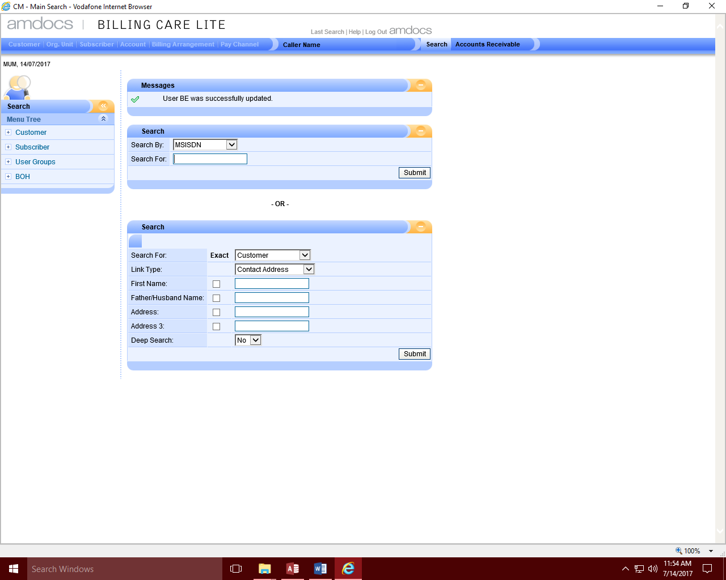

1. **Navigating to the Search screen**

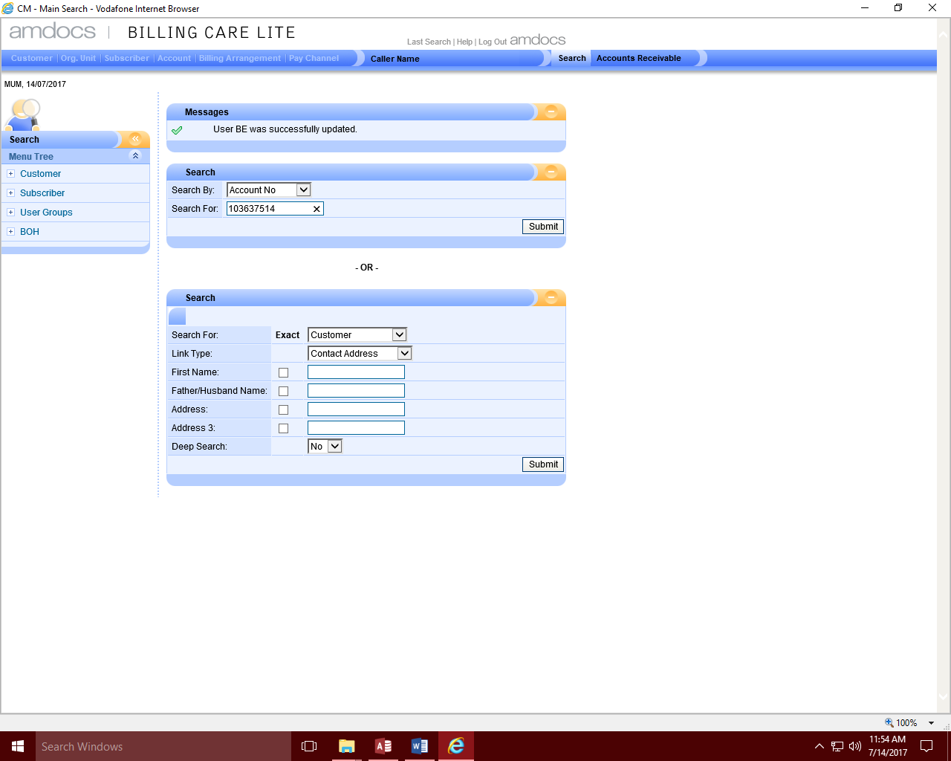

1. **Selecting the Account number search criteria and populating the account number**

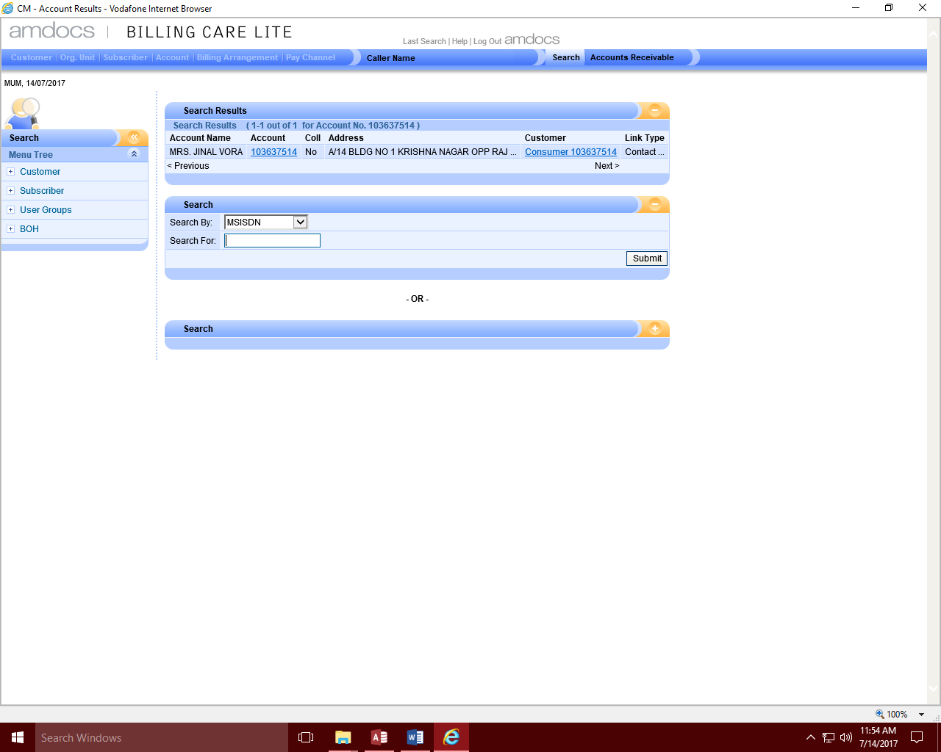

1. **Account details getting displayed after submitting the account number**

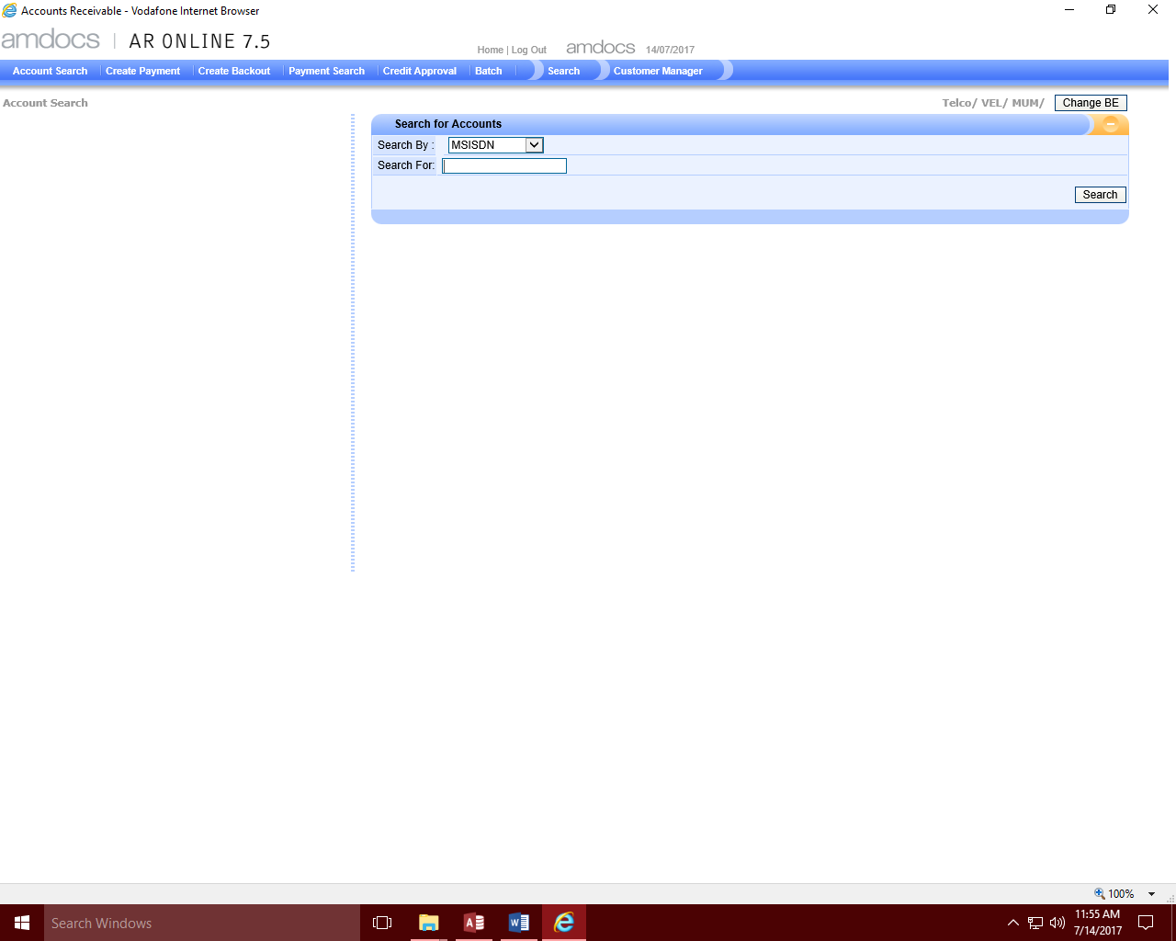

1. **Navigating to Accounts search screen after clicking Accounts Receivable option**

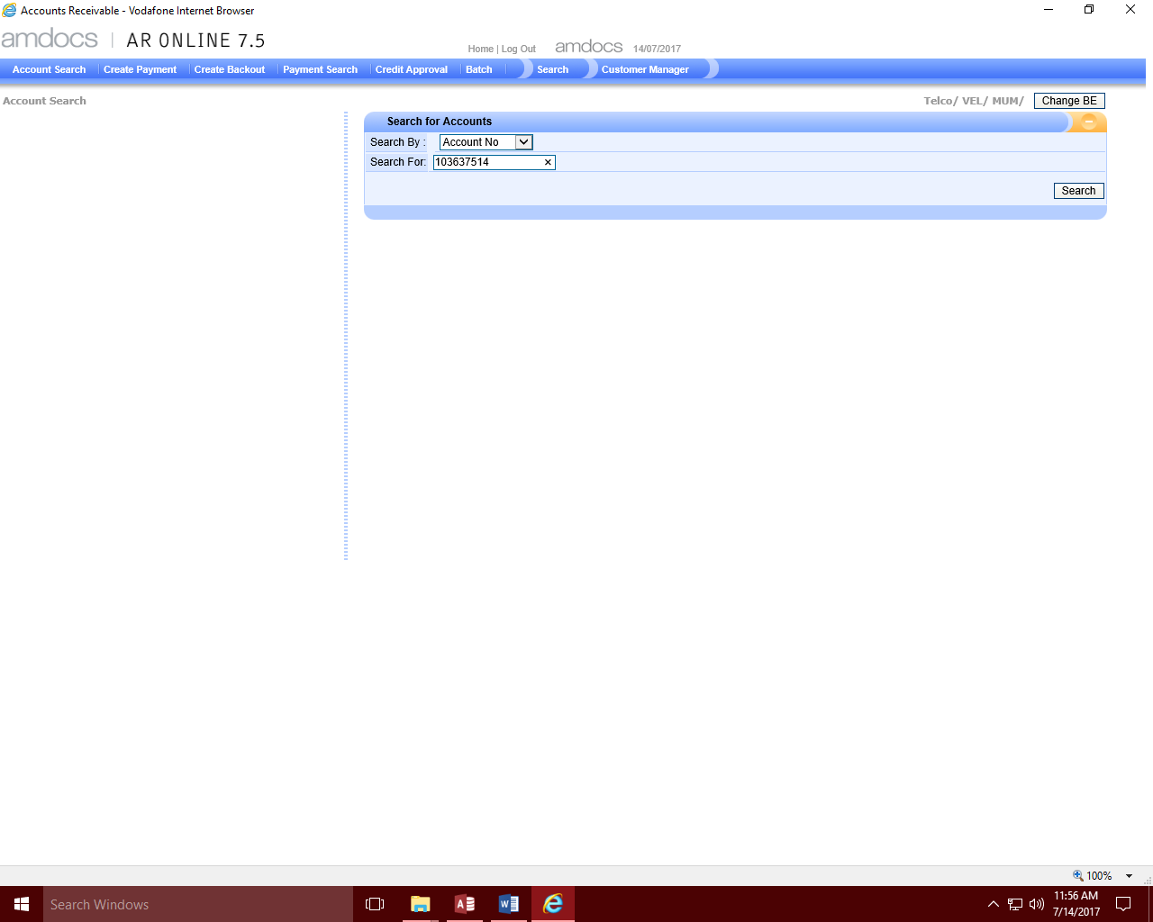

1. **Selecting the Account number search criteria and populating the account number**

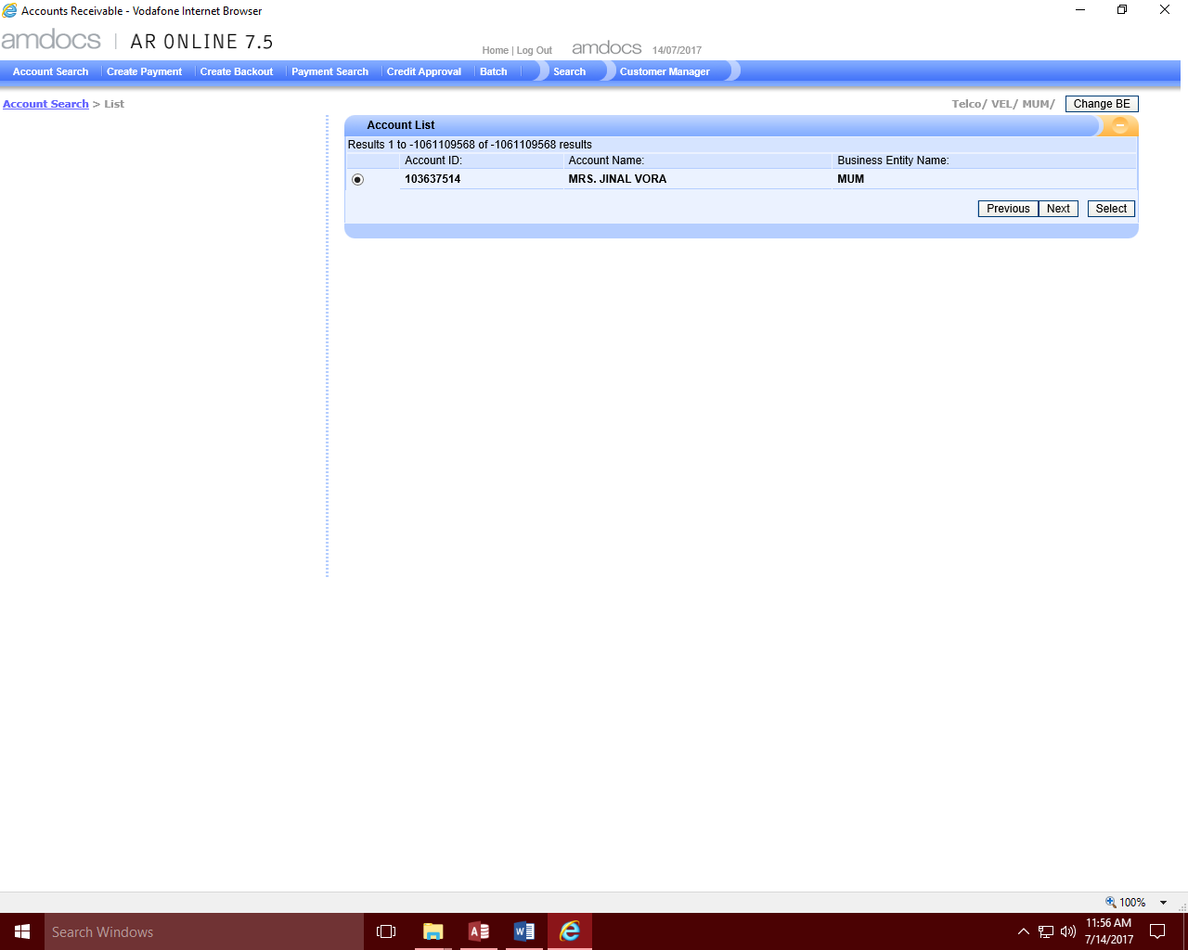

1. **Listing the Accounts on clicking the search button**

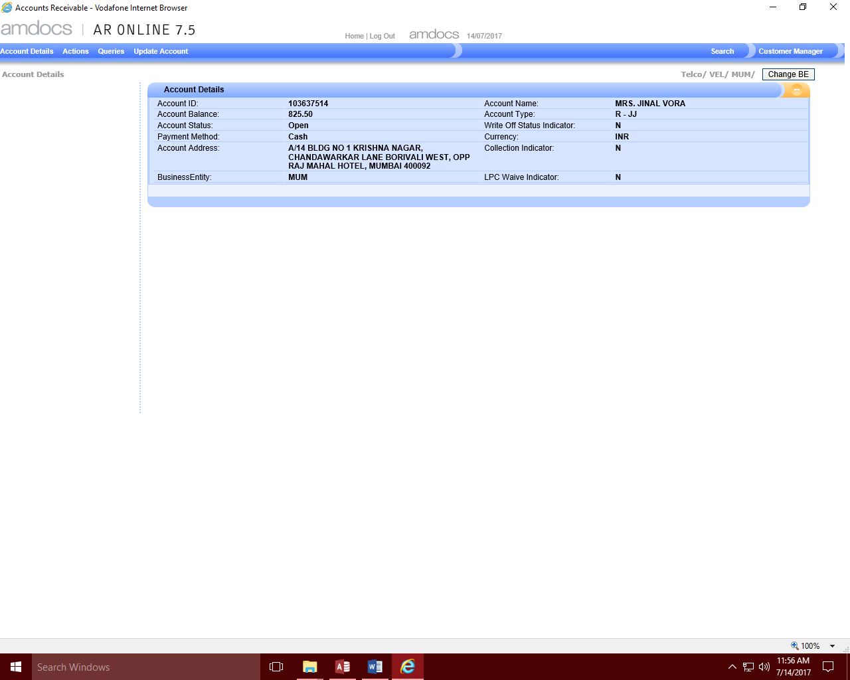

1. **Displaying the accounts detail information on clicking the select button**

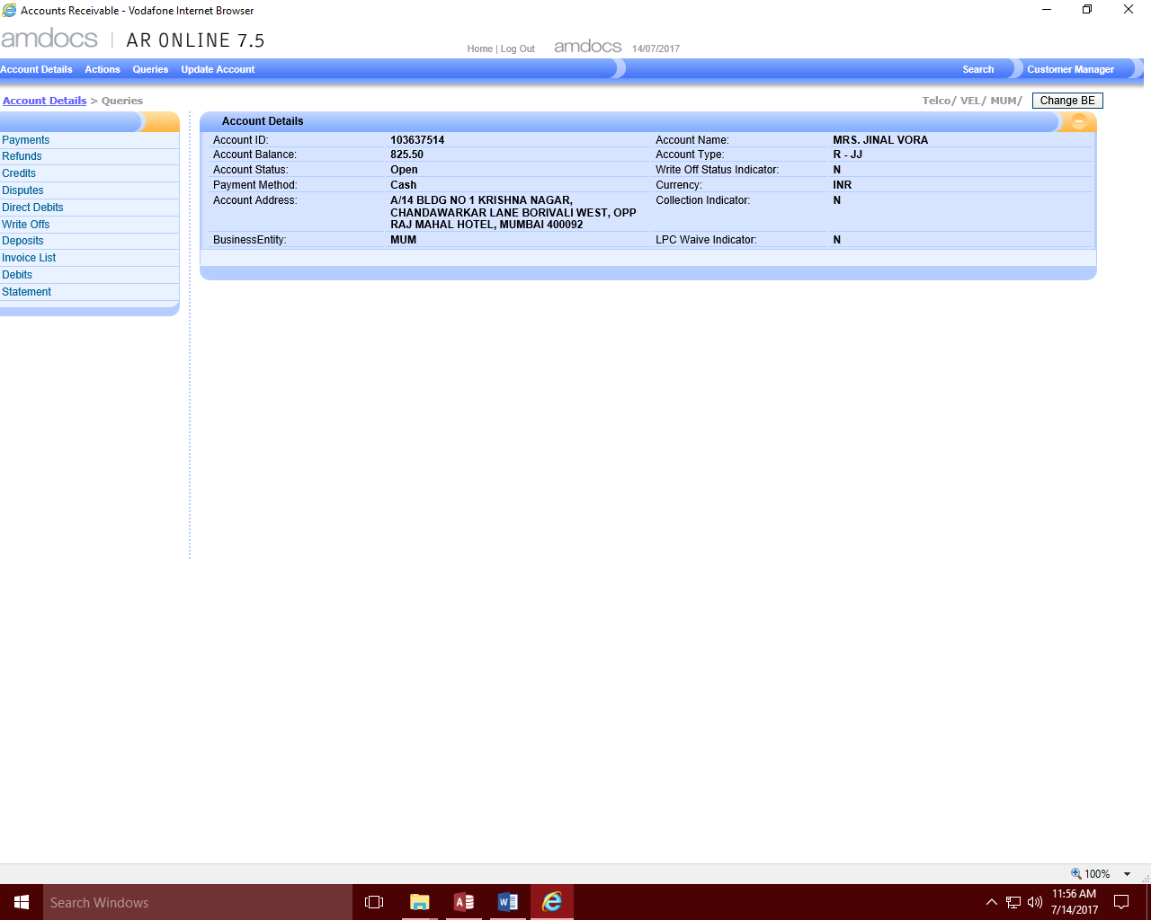

1. **Display on clicking the Queries Option**

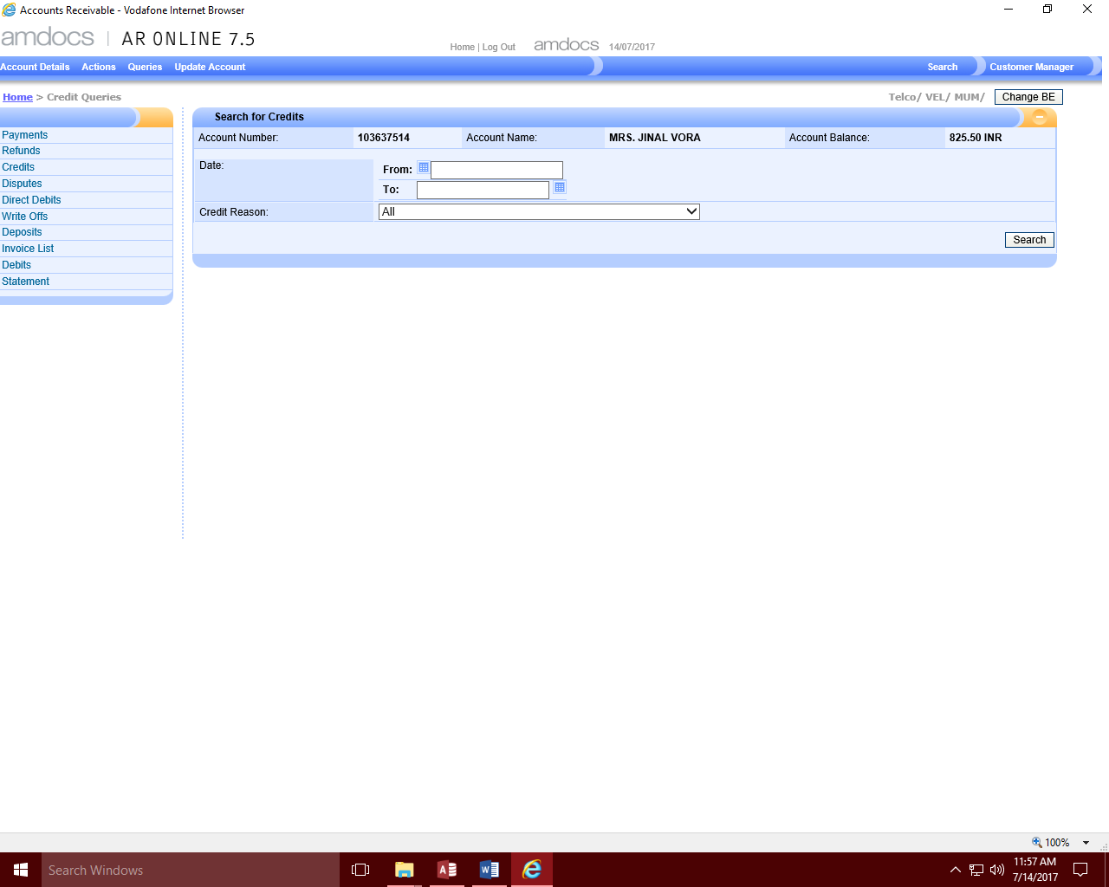

1. **Navigating to the Search Credits screen on clicking Credits**

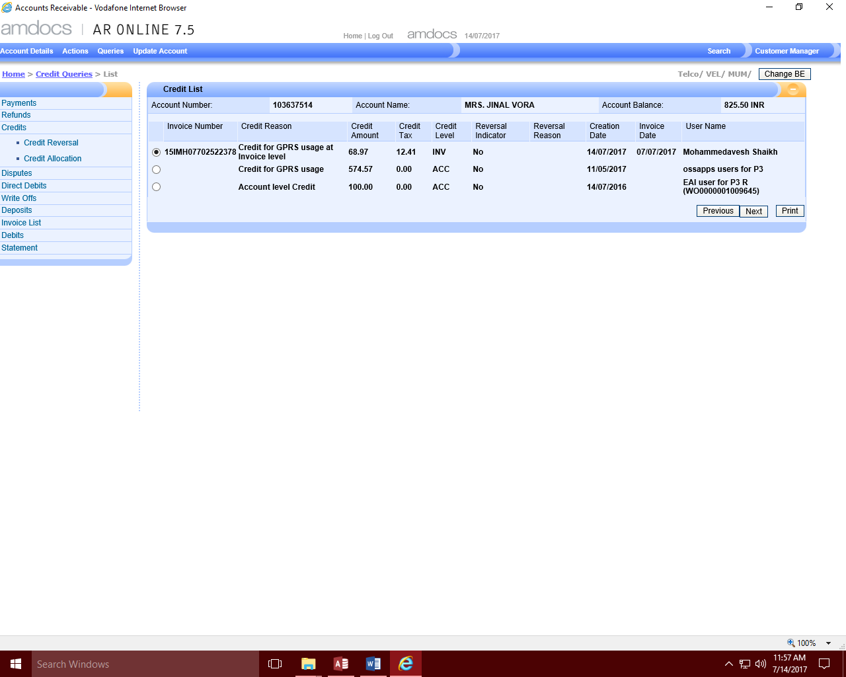

1. **Displaying Search Results on clicking Credit Search**

**Duplicate Amount detected by the tool:**

**Screen navigation is stopped, the request file is copied to the DuplicateCases folder and DuplicateCasesDuplicateSRs.tx file is appended with the request information.**

